

Submitted By:
Umair Umar CE-25-107
Assignment:
CA Lab No. 2
Submitted To:
Mehmood
For the fulfillment of,
Circuit Analysis Lab
Department of Computer Engineering
University of Engineering and Technology, Lahore

Circuit Analysis - Lab 2

Experiment #1 Circuit A
Components: R1 = 5.1 kO, R2 = 3.3 kO (series) | Vin = 5 V p-p, f = 100 Hz

Calculations:
Total resistance: Rtotal = 5.1 + 3.3 = 8.4 kO
VR1 (p-p) = 5 x 5.1/8.4 = 3.04 V VR1 (rms) = 3.04/2.828 = 1.07 V
VR2 (p-p) = 5 x 3.3/8.4 = 1.96 V VR2 (rms) = 1.96/2.828 = 0.695 V

Data Table:
Resistor | Input Voltage | RMS Voltage | P-P Voltage
R1 | 5 V | 1.07 V | 3.04 V
R2 | 5 V | 0.695 V | 1.96 V

Oscilloscope Settings:
Input: V/div = 0.5 V/div | Resistors: V/div = 0.2 V/div | Time/div = 10 ms/div (T = 10 ms => f = 100 Hz)
One complete cycle of the waveform spans exactly 1 horizontal division on the screen.

Waveform Graphs:

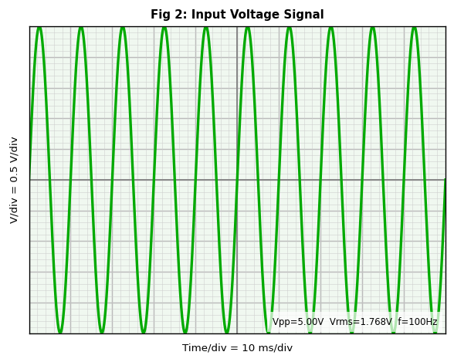  Figure 2: Input Voltage Signal (5V p-p, 100Hz) | 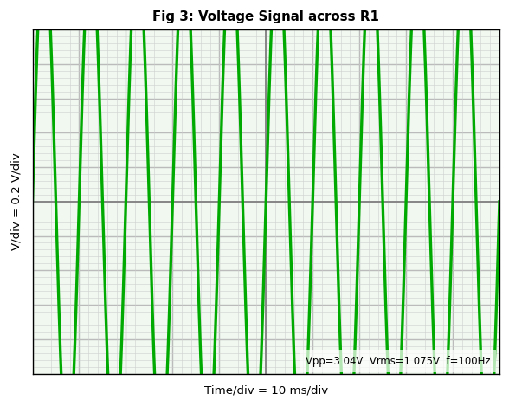  Figure 3: Voltage Signal across R1 (3.04V p-p)

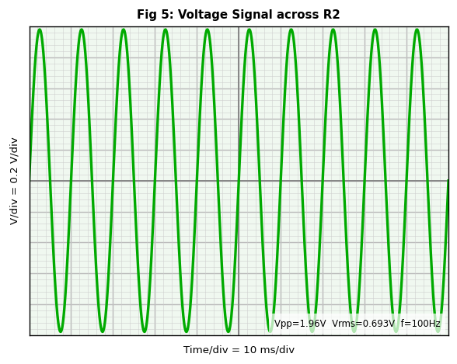  Figure 5: Voltage Signal across R2 (1.96V p-p) | 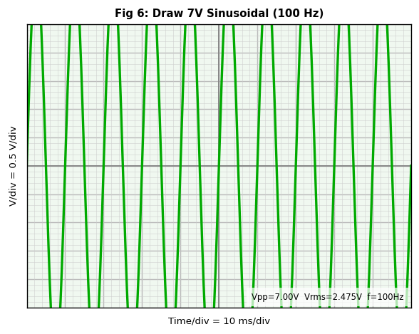  Figure 6: Draw 7V Sinusoidal (100Hz)

Experiment #2 Circuit B
Components: R1 = 4.7 kO, R2 = 3.3 kO, R3 = 5.1 kO (series) | Vin = 7 V p-p, f = 200 Hz

Calculations:
Total resistance: Rtotal = 4.7 + 3.3 + 5.1 = 13.1 kO
VR1 (p-p) = 7 x 4.7/13.1 = 2.51 V VR1 (rms) = 0.888 V
VR2 (p-p) = 7 x 3.3/13.1 = 1.76 V VR2 (rms) = 0.624 V
VR3 (p-p) = 7 x 5.1/13.1 = 2.73 V VR3 (rms) = 0.964 V
VR1+R2 (p-p) = 4.27 V VR1+R2 (rms) = 1.511 V
VR2+R3 (p-p) = 4.49 V VR2+R3 (rms) = 1.588 V

Data Table:
Resistor | Input Voltage | RMS Voltage | P-P Voltage
R1 | 7 V | 0.888 V | 2.51 V
R2 | 7 V | 0.624 V | 1.76 V
R3 | 7 V | 0.964 V | 2.73 V
R1 and R2 | 7 V | 1.511 V | 4.27 V
R2 and R3 | 7 V | 1.588 V | 4.49 V

Oscilloscope Settings:
Input: V/div = 0.5 V/div | Resistors: V/div = 0.2 V/div | Time/div = 10 ms/div
T = 5 ms, so one cycle spans 0.5 divisions. Two complete sine waves appear per horizontal division.

Waveform Graphs:

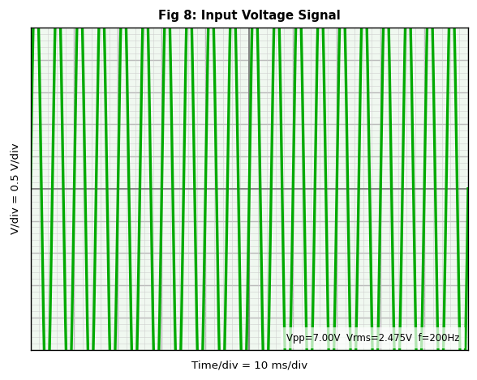  Figure 8: Input Voltage Signal (7V p-p, 200Hz) | 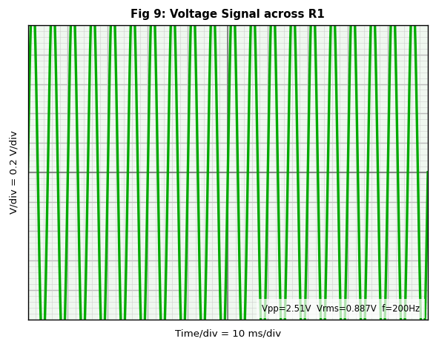  Figure 9: Voltage Signal across R1 (2.51V p-p)

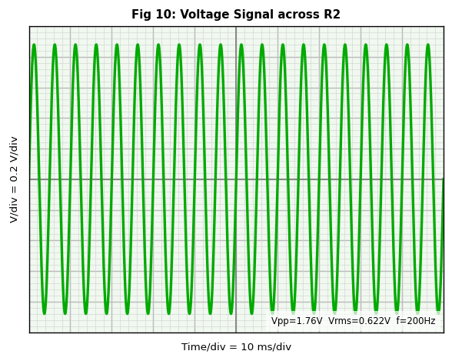  Figure 10: Voltage Signal across R2 (1.76V p-p) | 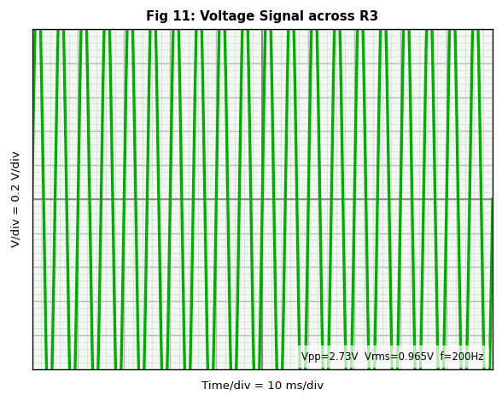  Figure 11: Voltage Signal across R3 (2.73V p-p)

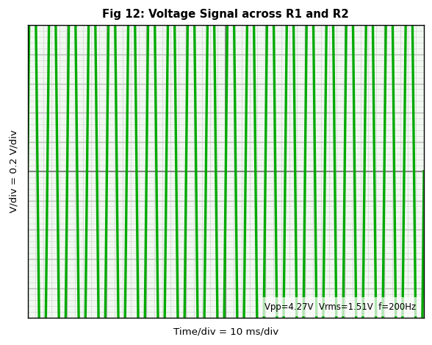  Figure 12: Voltage Signal across R1 and R2 (4.27V p-p) | 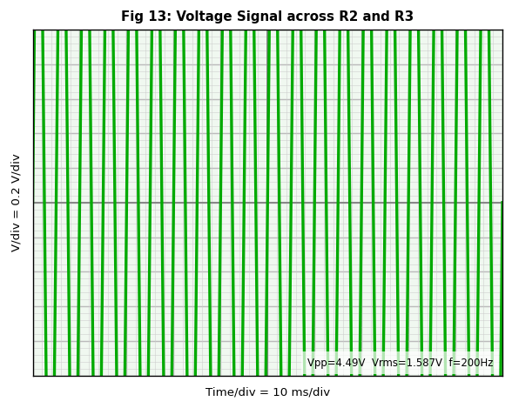  Figure 13: Voltage Signal across R2 and R3 (4.49V p-p)

Post Lab Questions

1. Define Ohm's Law
Ohm's Law states that the voltage (V) across a conductor is directly proportional to the current (I) flowing through it, provided temperature remains constant: V = I x R. If voltage increases, current increases proportionally.

2. What is a Resistor?
A resistor is a passive two-terminal component that opposes electric current. Measured in ohms (O), it controls current levels, divides voltages, and protects other components. It dissipates electrical energy as heat.

3. How Does a Resistor Work?
When electrons flow through the resistive material, they collide with atoms, slowing down and converting electrical energy into heat. The resistance depends on the material, length, and cross-sectional area. Higher resistance means fewer electrons pass for a given voltage.

4. Inference from Input and Output Waveforms on the Oscilloscope
All waveforms are sinusoidal at the same frequency as the source. Since the circuit is purely resistive, there is no phase shift between input and output. The amplitude across each resistor is smaller than the input, proportional to that resistor's share of total resistance. The sum of all voltage drops equals the input voltage (KVL). Resistors do not distort the waveform shape.

5. Calculations for the 7 V Input Signal (Experiment 2, 200 Hz)

a) Voltage Calculations (V/div = 0.5 V/div):
Vpp = 14 boxes x 0.5 V/div = 7 V p-p
Vp = 7 / 2 = 3.5 V
Vrms = 3.5 / sqrt(2) = 2.475 V

b) Frequency / Period Calculations (time/div = 10 ms/div):
One complete cycle spans 0.5 div on screen.
T = 0.5 div x 10 ms/div = 5 ms
f = 1 / 0.005 = 200 Hz (matches signal generator)

c) Current Calculation (Ohm's Law):
Rtotal = 13,100 O
Ip = 3.5 / 13100 = 0.267 mA
Irms = 2.475 / 13100 = 0.189 mA
Ipp = 7.0 / 13100 = 0.534 mA
The same current flows through R1, R2, and R3 (series circuit).

